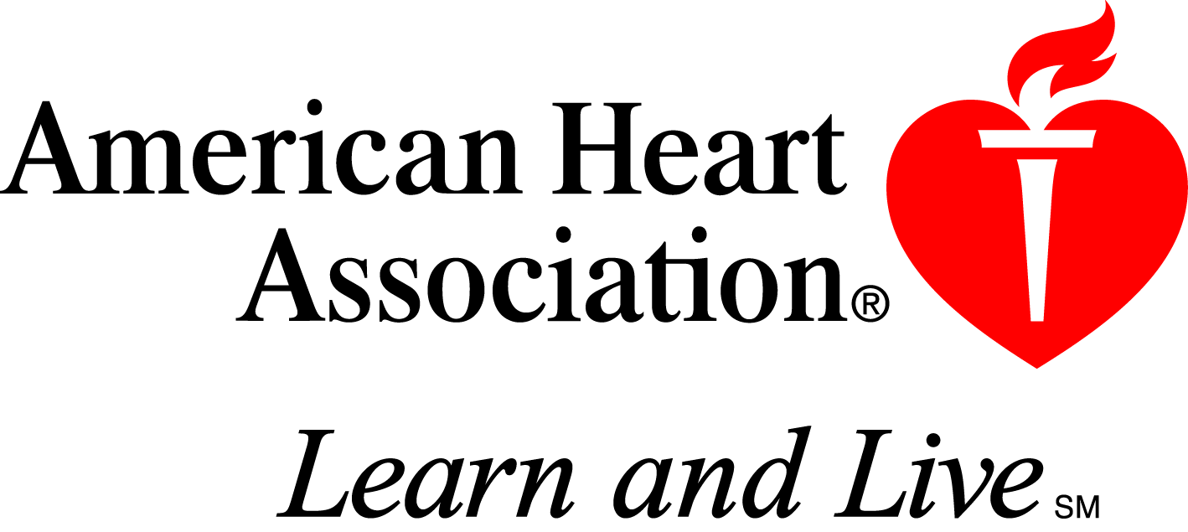

Credit Card Transaction Form

Please fill in all fields with the appropriate information and fax to Cathy Berrells in the Finance Department.
Fax# is (214) 706-5202

To: Cathy Berrells From: Lauren Rowell

Date:

***********************************************************************************************

Cardholder Name and Address:

Cardholder Name: ___________________________________________

Cardholder Address: ___________________________________________

____________________________________________

City: ___________________________ State: _________ Zipcode: ____________________

Telephone Number: __________________________________

Credit Card Type: MasterCard Visa American Express Discover (circle one)

Credit Card #: ________________________________________ Exp Date: __________

Cardholder Signature: ___________________________________________

Amount to charge: $
Description of service/ product: For CVN 40th Anniversary Educational Fund: 402354.3174.59059

__________________________________________________________

************************************************************************************************
American Heart Association 7272 Greenville Avenue Dallas, TX 75231 1-214-373-6300

